Excerpt from: https://www.zerohedge.com/markets/deep-ship-deep-dive-supply-chain-crisis

Too Big to Sail (Container 2 of 6)
Shipping, like much else, has become much larger over the years. Small feeder ships of up to 1,000TEU are dwarfed by the largest Ultra-Large Container Vessels (ULCVs), which start from 14,501 TEUS up, and are larger than the US Navy’s aircraft carriers.
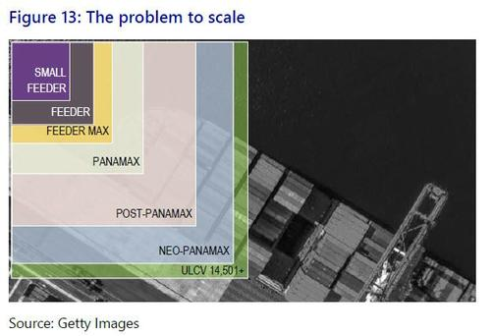
Of course, there is a reason for this gigantism: economy of scale. It is a sound argument. However, the same was said in other industries where painful experience, after the fact, has shown such commercial logic is not the best template for systemic stability. In banking we are aware of the phenomenon, and danger, of “Too Big to Fail”. In shipping, ULCVs and their associated industry patterns could perhaps be seen as representing “Too Big to Sail”.
After all, there are downsides to so much topside beyond the obvious incident with the Ever Given earlier in the year:
- ULVCs cannot fit through the Panama Canal;
- Not all ports can handle ULCVs;
- They are slow at sea;
- They are slow to load and unload;
- They require more complex cargo placement / handling;
- They force carriers to maximize efficiency to cover costs;
- They force all in-land logistics to adapt to their scale;
- They force a hub-and-spokes global trade model; and
- They are vulnerable to accident or disruption, i.e., they were designed for an entirely peaceful shipping environment at a time of rising geopolitical tensions (which we will return to later).
In short, current ULCV hub-and-spokes trade models are the antithesis of a nimble, distributed, flexible, resilient system, and actually help create and exacerbate the cascading supply-chain failures we are currently experiencing.
However, we do not have a global shipping regulator to order shippers to change their commercial practices!
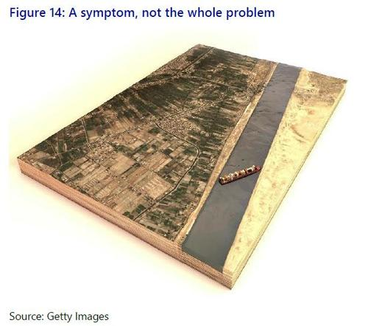
Specifically, building ULVCs takes time, and shipyard capacity is more limited.
As shown, the issue is not so much a lack of ULCVs, but limited capacity from ports onwards. That means we need to expand ports, which is a far slower and more difficult process than adding new containers or ships, given the constraints of geography, and the layers of local and international planning and politics involved in such developments. There is also then a need for matching warehousing, roads, trucks, truckers, rail, and retailer warehousing, etc. As we already see today, just finding truckers is already a huge issue in many economies.
Meanwhile, any incident that impacts on a ULCV port –
- a Covid lockdown,
- a weather event,
- power-cuts, or
- a physical action
-- exacerbates feedback loops of supply-chain disruption more than any one, or several, smaller ports servicing smaller feeder ships would do.
So why are we not adapting? Economic thinking, partly dictated by the need to survive in a tough industry; massive sunk costs; and equally massive vested interests – which we can collectively call “Too Big to Sail”. Naturally, some parties do not wish to move to a nimbler, less concentrated, more widely-distributed, locally-produced, more resilient supply-chain system --with lower economies of scale-- while some
do: and this is ultimately a political stand-off.
Crucially, nobody is going to make much-needed new investments in maritime logistics until they know what the future map of global production looks like. Post-Covid, do we still make most things in China, or will it be back in the US, EU, and Japan – or India, etc.? Are we Building Back Better? Where?
Resolving that will help resolve our shipping problems: but it will of course create lots of new ones while doing so.

